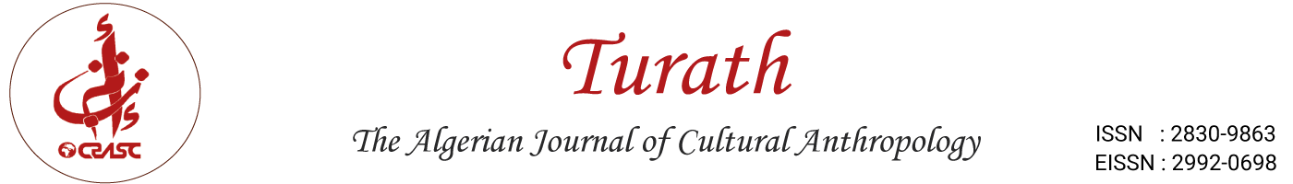

Manuscript Review Form

https://journals.crasc.dz/index.php/turath
https://asjp.cerist.dz/en/PresentationRevue/920

Instructions: Please complete this form and attach it alongside the ASJP review form. Submit both forms to the editor and the author.
Do not include your name anywhere in this document.
https://www.asjp.cerist.dz/en/login

Manuscript Details:
- Title: .................................................
- Date Review Submitted: ............................
- Manuscript ID: ....................................

The review process calls for reviewer summary recommendation and open narrative comment.

I. SUMMARY RECOMMENDATION: Please select one

_____ Accept: no revision needed

_____ Accept: minor revision needed

_____ Major revisions needed: suggest revision and resubmission; this might involve a second round of reviews

_____ Reject

If the authors revise as you suggest, would you be willing to review the revision?
___ Yes ___No

If article should be sent to a different journal, which one(s): ______________

Note: If recommending rejection, provide detailed reasons in the comments section for both the editor and the author (ASJP) . For acceptance or revision, offer specific guidance to improve the manuscript using the sections below.

II. NARRATIVE ASSESSMENT:
Provide a detailed assessment directed to the author(s), highlighting the manuscript’s strengths and weaknesses. Clearly identify unresolved issues and offer actionable suggestions for improvement. Consider the following criteria in your evaluation:

- Originality and Contribution:
Does the manuscript offer new findings, concepts, or theories? Alternatively, is it a fresh interpretation of an existing area of inquiry?

- Significance of Research Problem:
How important is the research problem? Is the purpose well-defined?

- Theoretical Frameworks and Literature Review:
Are the frameworks and literature reviews well-developed and appropriate? Has the author engaged with the relevant scholarship and used key sources effectively?

- Methodological Soundness:
Are the methods appropriate and rigorously applied to address the research problem?

- Inferences and Conclusions:
Are the conclusions well-supported and convincing? Are the theoretical and practical implications clearly articulated?

- Organisation and Readability:
Is the manuscript well-structured, coherent, and readable? Does it present a clear and logical argument? Is the writing style suitable for the purpose?

- Target Readership:
Who is the intended audience? Is the article aimed at a highly specialised readership or a broader interdisciplinary audience?

- Comments to the Author: Provide additional comments, including specific suggestions for improvement or areas requiring clarification.

