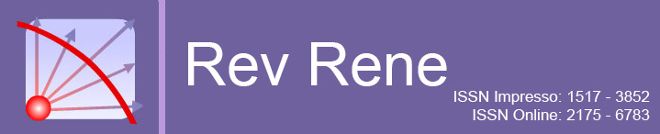

MANUSCRIPT ASSESSMENT INSTRUMENT

Article number:
Title:
Dear Reviewer,
We would like to request your collaboration by issuing an opinion on the article for possible publication in Rev Rene. This instrument has three parts: 1, 2 and 3. Please, once you your evaluation, return it at the expected date.

PART 1: ARTICLE ANALYSIS

Fill out the instrument with following captions: Y = Yes; N = No; P = Partially; NA = Non- Non-applicable

Y for yes | N for not | P for partially | NA for non-applicable

1. Title
Concise and understandable
Show the text content

2. Abstract
Clarity and conciseness in the text
Have the key objectives
Explain the method used
Have the main results
Conclusions related to objectives

3. Descriptors
Have adequate amount (3 to 5 descriptors)
Have international abbreviations
Have commercial names of products or substances

4. Body of the manuscript
Introduction
Clear study question(s)
Justify the study
Topic contextualization in logical sequence
Formulate objectives and/or hypotheses
Methods
Have the theoretical framework
Have the study type
Suitable for study type
Describe selection/composition of sample/participants
Describe data collection instrument
Describe data collection process clearly
Describe the analysis method
Describe statistical analysis
Results and Discussion
Have separated section
Clarity in description
Consistency with the proposed objectives
Connection with other authors / studies
Describe generalizations and/or implications related to the data obtained
Consistent interpretations
Enough tables and figures to illustrate the study
Tables and figures concisely, logically placed and without duplication of text information
Tables and figures follow the norms of the Journal: maximum of five
Reflective synthesis, referring to practical applications or identified limitations
Conclusion
Consistency with development and study findings

4. Characteristics of text writing
Proper spelling and verb agreement
Concise, accurate and clear language
Coherent text

5. References
According to the topic
Updated, relevant and selective
Sufficient amount
Numbered and indicated according to the citation sequence in the text

6. Article Classification
Research article
Review article
Another

PART 2: REVIEWER'S CONCLUSIONS
Decision
Approved for publication without restriction
Suitable for publication if requested adjustments are met
Not suitable for publication

PART 3: ARGUMENTS
Does the approved/indicated/rejected article contribute to the expansion of nursing knowledge? Justify.

Comments and arguments from the reviewer to the author

Comments from the reviewer to the section editor

Rev Rene appreciates your participation in this review

